1.a Docker info

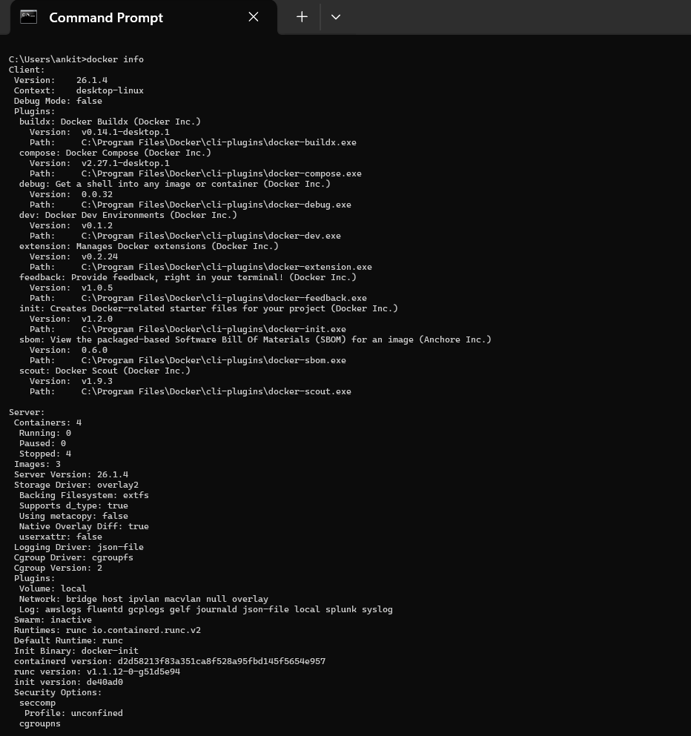

1.b Docker version

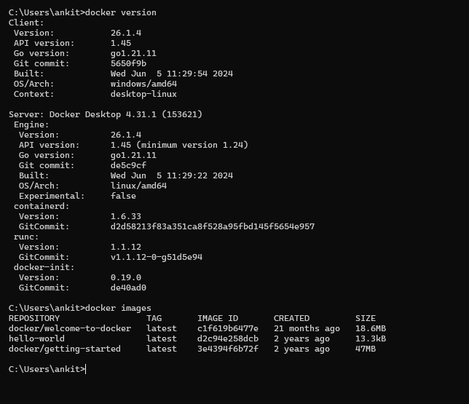

2.1 Docker images

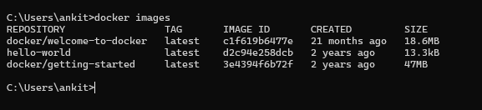

3.1 search for an image across all repositories

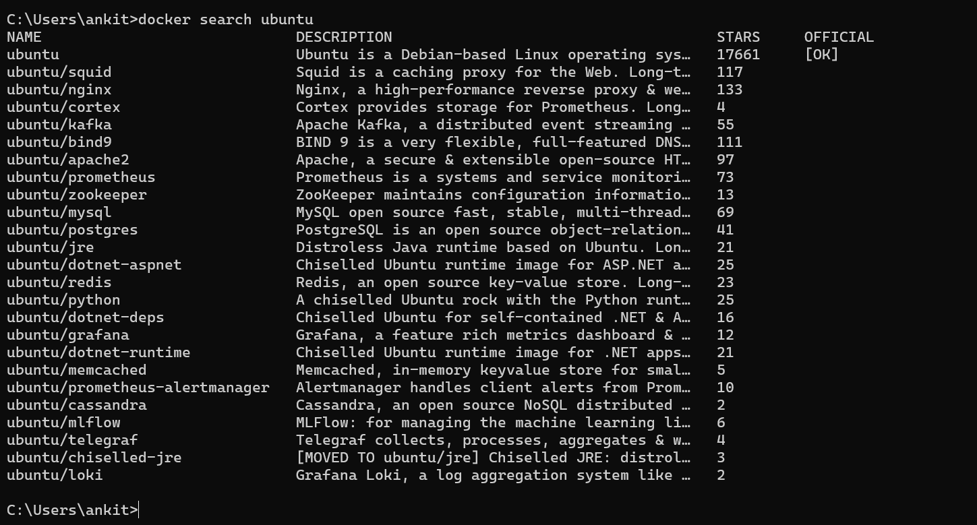

4.1 pull the latest ubuntu image from hub

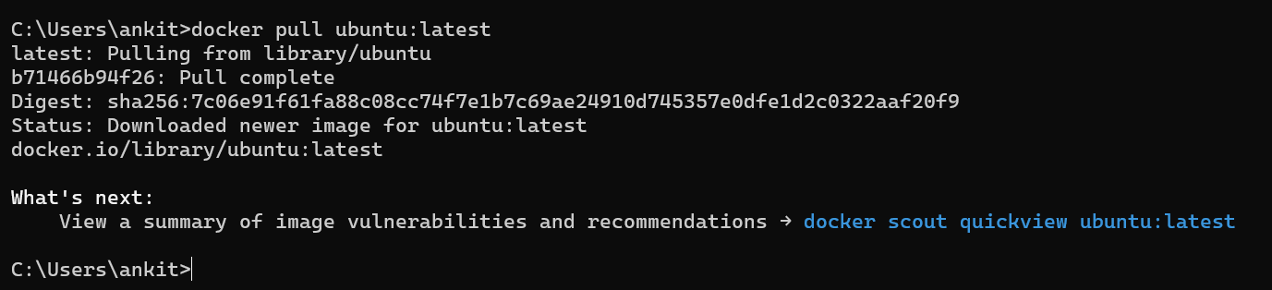

5.1 view the pulled image

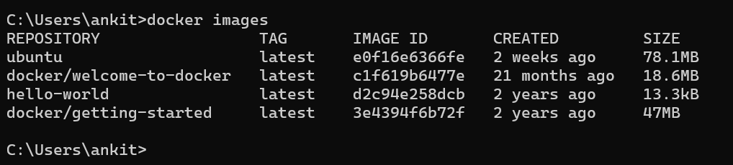

6.1 create a new container from the pulled image



7.1 view all containers in the host system

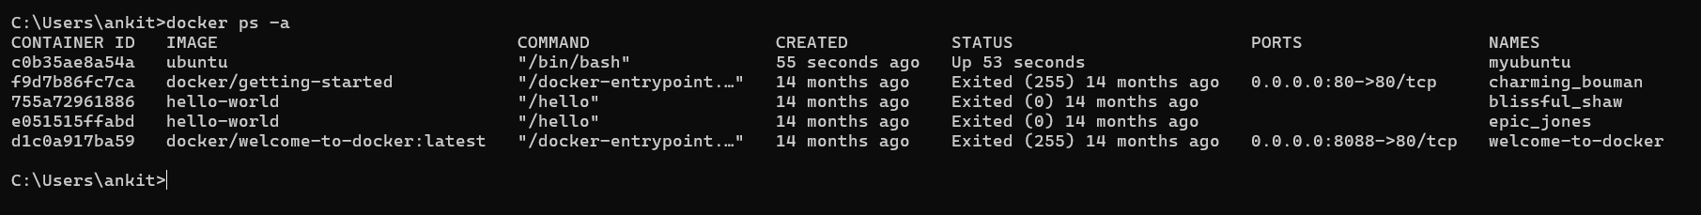

8.1 stop the running container



9.1 start the container again

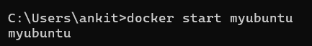

10.1 get into the Shell interpreter of the container



11 run a few commands

1. Apt update -y

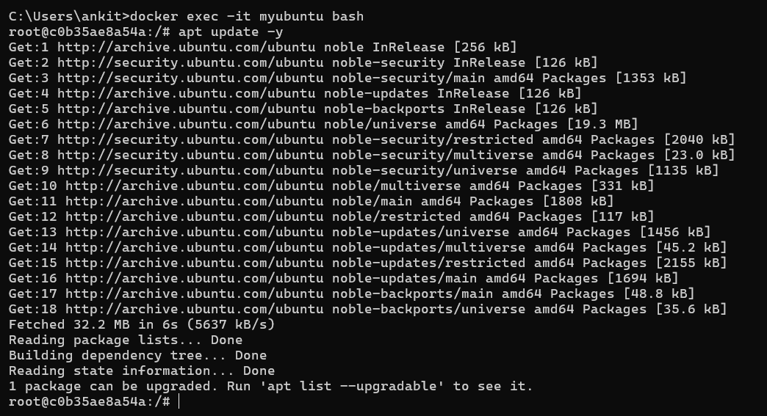

11.2 apt install -y python3

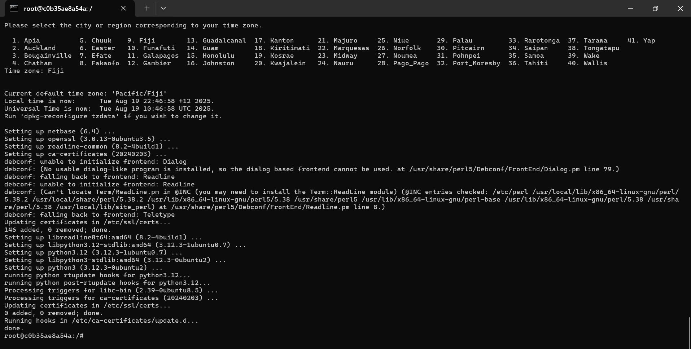

11.3 exit

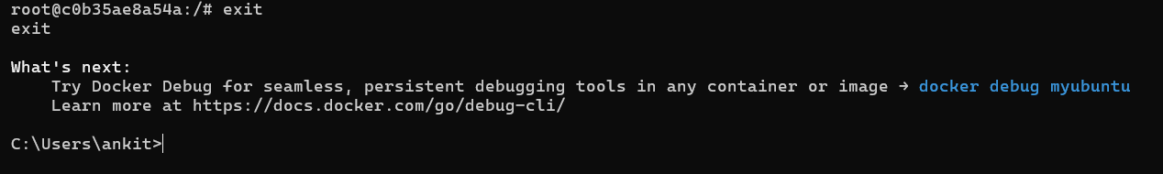

12. Commit the container into a new image



13.1 run a new container from the image ubuntu-python3



13.2 Check Python version inside the new container

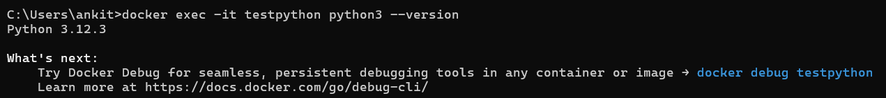

14.remove the previously pulled ubuntu image and observe the result



The image ubuntu **cannot be removed** because the container myubuntu is still using it

Part B: running containerized applications

15.1 run a containerized application hosted in the dockerhub

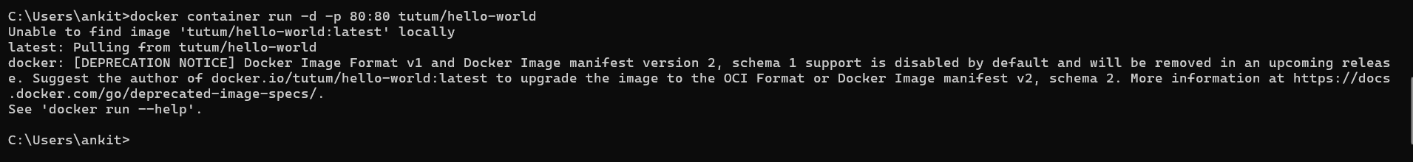

16.1 find out the name of the container

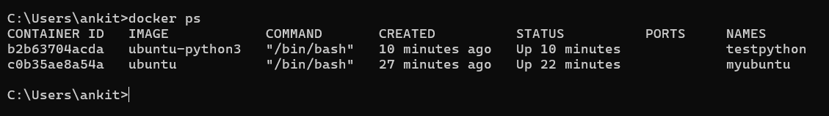

17.1 execute the application using curl command

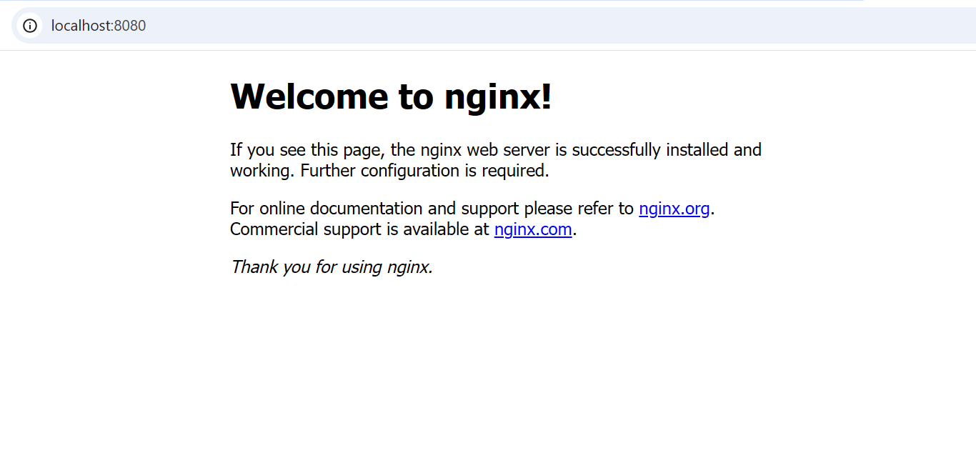

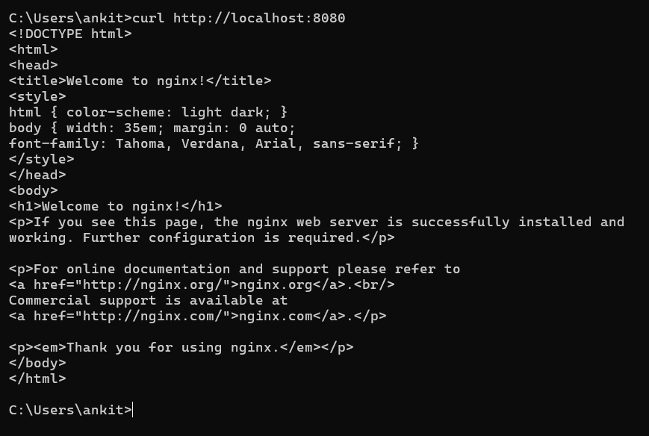

18. Check logs

